**SOLIDITY PROGRAMING**

**Practical No.3**

1.Write a solidity smart contract to display hello world message.

pragma solidity ^0.5.0; contract HelloWorld { constructor () public {

}

function getResult() public view returns(string memory){ return 'Hello World';

}

}

Output:

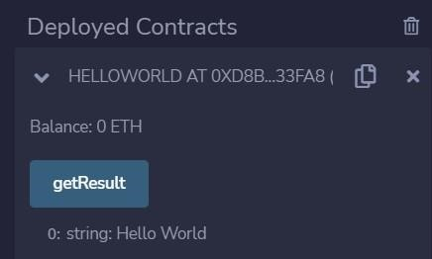

2. Write a solidity smart contract to demonstrate state variable, local variable and global variable.

pragma solidity ^0.5.0; contract SolidityTest { uint storedData; // State variable constructor() public { storedData = 10;

}

function getResult() public view returns(uint){

uint a = 1; // local variable uint b = 2; uint result = a + b; return storedData; //access the state variable

}

}

Output:

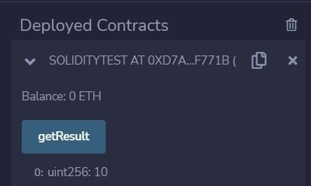

3. Write a solidity smart contract to demonstrate getter and setter methods.

pragma solidity ^0.5.0; contract GetAndSet{ string name; uint age; function GetandSet() public {

}

function set(string memory newName, uint newAge) public { name = newName; age = newAge;

}

function get() public view returns (string memory, uint) { return (name,age);

}

}

Output:

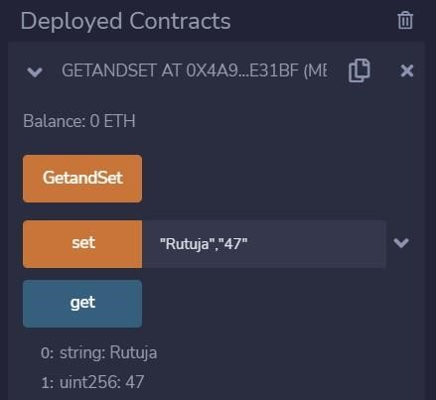

4.Write a solidity smart contract to demonstrate function modifier.

pragma solidity ^0.5.0;

contract Owner { address owner; constructor() public { owner = msg.sender;

}

modifier onlyOwner { require(msg.sender == owner);

}

modifier costs(uint price) { if (msg.value >= price) {

}

}

function getPrice() public view returns(uint price){ return price;

}

}

contract Register is Owner { mapping (address => bool) registeredAddresses; uint price; constructor(uint initialPrice) public { price = initialPrice; }

function register() public payable costs(price) { registeredAddresses[msg.sender] = true;

}

function changePrice(uint _price) public onlyOwner { price = _price;

}

}

Output:

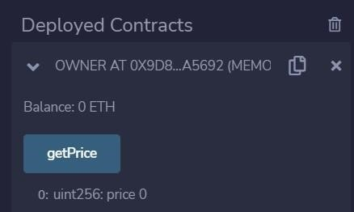

5.Write a solidity smart contract to demonstrate use of structure.

pragma solidity ^0.5.0; contract test { struct Book { string title; string author; uint book_id; } Book book; function setBook() public { book = Book('Learn Java', 'TP', 100012); } function getBookId() public view returns (uint) { return book.book_id; } } Output:

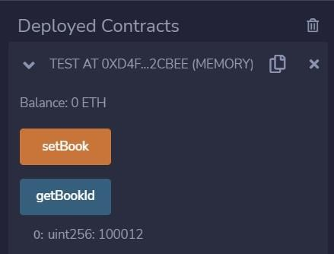

6. Write a solidity smart contract to calculate percentage of marks obtained by students for six subject in final examination.

pragma solidity ^0.5.0; contract percentage{ uint sub_1;uint sub_2; uint sub_3;uint sub_4;uint sub_5;uint sub_6;uint total=600; uint marksObtained;

function set(uint s1,uint s2 ,uint s3,uint s4,uint s5,uint s6) public { sub_1=s1; sub_2=s2; sub_3=s3; sub_4=s4; sub_5=s5; sub_6=s6;

marksObtained=sub_1+sub_2+sub_3+sub_4+sub_5+sub_6; marksObtained=marksObtained*100;

}

function getPercentage() public view returns (uint) { uint percent=marksObtained/total; return percent;

}

}

Output:

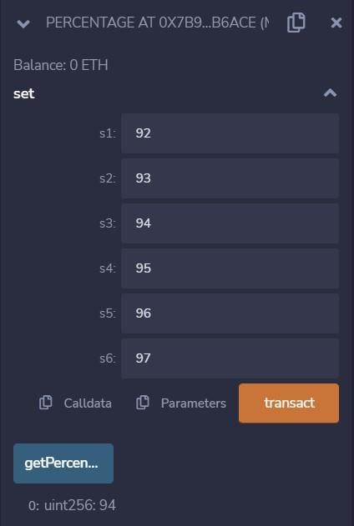

7.Write a solidity smart contract to find the factorial of entered number.

pragma solidity ^0.5.0; contract factorial{ uint number; function set(uint n) public { number=n;

}

function getFactorial() public view returns (uint) { uint f=1; for(uint i=2;i<=number;i++){ f=f*i;

}

return f;

}

}

Output:

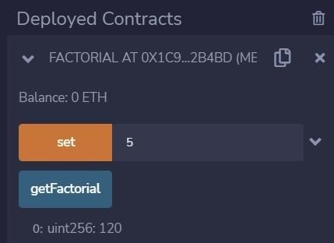

8.Write a solidity smart contract to check whether entered number is palindrome or not.

pragma solidity ^0.5.0; contract palindrome{ uint number; function set(uint n) public { number=n;

}

function getPalindrome() public view returns (bool ) { uint r; uint n=number; uint reverseNumber=0; while(n>0){ r=n%10; reverseNumber=reverseNumber*10+r; n=n/10;

}

if(reverseNumber==number){

return true;

}

else return false;

}

}

Output:

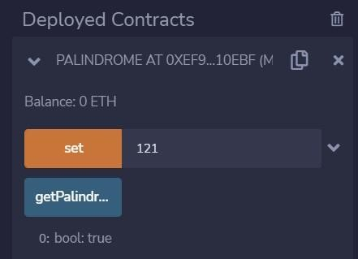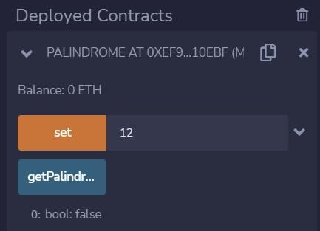

9. Write a solidity smart contract to generate Fibonacci Series up to given number.

pragma solidity ^0.5.0; contract fibonacci{ uint number_of_terms; function set (uint n) public { number_of_terms=n;

}

function getFiboSeries() public view returns (uint[] memory ) { uint a=0; uint b=1; uint c;

uint[] memory result=new uint[](number_of_terms); result[0]=a; result[1]=b;

for(uint i=2;i<number_of_terms;i++){ c=a+b; result[i]=c; a=b; b=c;

}

return result;

}

}

Output:

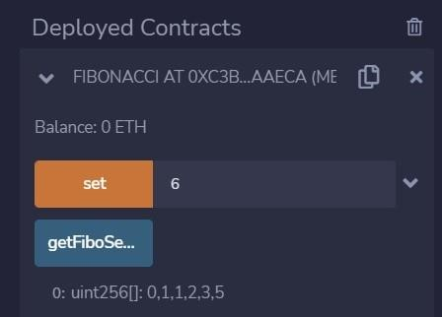

10.Write a solidity smart contract to check whether entered number is prime number or not.

pragma solidity ^0.5.0; contract prime{

function isPrime(uint n) public view returns (string memory ) { string memory message=""; if(n==0){ return "Invalid input.";

}

else if (n==1){

return "1 is neither prime nor composite.";

}

else if(n==2){

return "Entered Number is prime.";

}

else{ bool flag=true; for(uint i=2;i<=n/2;i++ ){ if(n%i==0){ flag=false; break;

}

}

if(flag){

return "Entered Number is prime.";

}

else{

return "Entered Number is not prime.";

}

}

} }

Output:

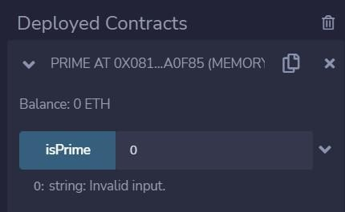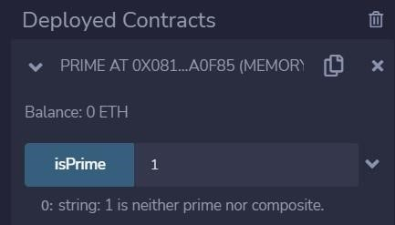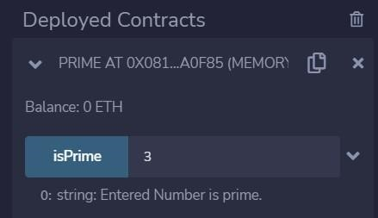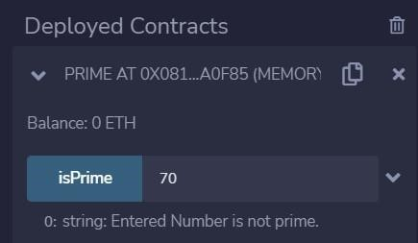

11.Write a solidity smart contract to create arithmetic calculator which includes functions for operations addition, subtraction, multiplication, division etc.

pragma solidity ^0.5.0; contract arithmetic_calci{

function add(uint n1,uint n2) public view returns (uint result ) { return n1+n2;

}

function sub(uint n1,uint n2) public view returns (uint result ) { return n1n2;

}

function mul(uint n1,uint n2) public view returns (uint result ) { return n1*n2;

}

function div(uint n1,uint n2) public view returns (uint result ) { return n1/n2;

}

function modulus(uint n1,uint n2) public view returns (uint result ) { return n1%n2;

}

Output:

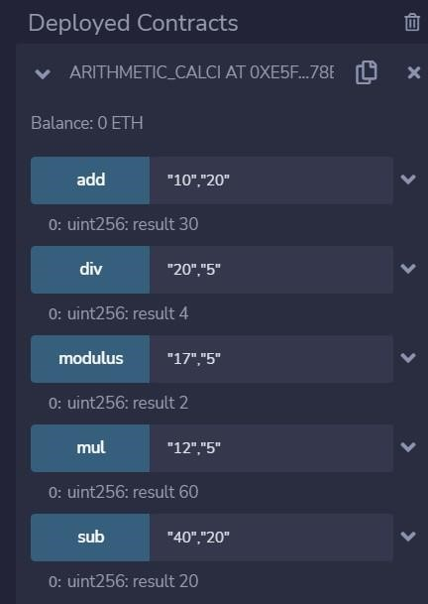

12.Write a solidity smart contract to demonstrate view function and pure function.

pragma solidity ^0.5.0; contract inbuilt_function_demo{

function callAddMod(uint n1,uint n2,uint n3) public pure returns(uint){ return addmod(n1,n2,n3);

}

function callMulMod(uint n1,uint n2,uint n3) public pure returns(uint){ return mulmod(n1,n2,n3);

}

}

Output:

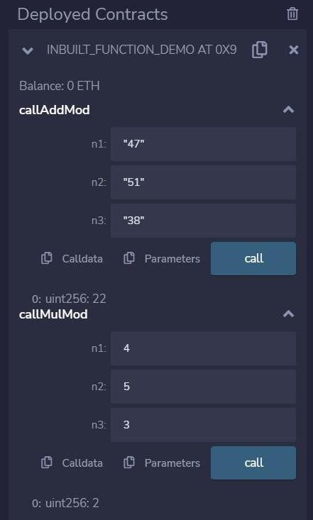

13.Write a solidity smart contract to demonstrate inbuilt mathematical functions.

pragma solidity ^0.5.0; contract C {

//private state variable uint private data;

//public state variable uint public info; //constructor constructor() public { info = 10;

}

//private function function increment(uint a) private pure returns(uint) { return a + 1; }

//public function

function updateData(uint a) public { data = a; } function getData() public view returns(uint) { return data; } function compute(uint a, uint b) internal pure returns (uint) { return a + b; }

}

//Derived Contract contract

E is C { uint private result; C private c; constructor() public { c = new C();

}

function getComputedResult() public { result = compute(3, 5);

}

function getResult() public view returns(uint) { return result; } function getData() public view returns(uint) { return c.info(); }

}

Output:

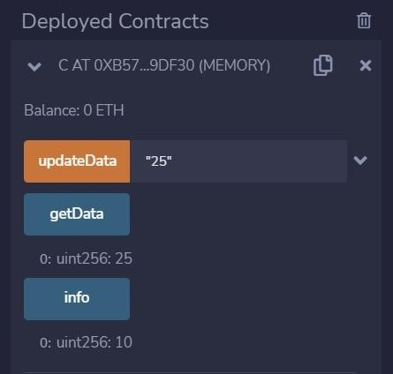

14.Write a solidity smart contract to demonstrate inheritance in contract.

pragma solidity ^0.5.0; contract C {

//private state variable uint private data;

//public state variable uint public info; //constructor constructor() public { info = 10;

}

//private function function increment(uint a) private pure returns(uint) { return a + 1; }

//public function

function updateData(uint a) public { data = a; } function getData() public view returns(uint) { return data; } function compute(uint a, uint b) internal pure returns (uint) { return a + b; }

}

//Derived Contract contract

E is C { uint private result; C private c; constructor() public { c = new C();

}

function getComputedResult() public { result = compute(3, 5);

}

function getResult() public view returns(uint) { return result; } function getData() public view returns(uint) { return c.info(); }

}

Output:



15.Write a solidity smart contract to demonstrate events.

pragma solidity ^0.5.0; contract eventDemo{

event Log(address indexed sender, string message); event AnotherLog(); function test() public { emit

Log(msg.sender, "Hello World!"); emit Log(msg.sender, "Hello EVM!"); emit AnotherLog();

}

}

Output:

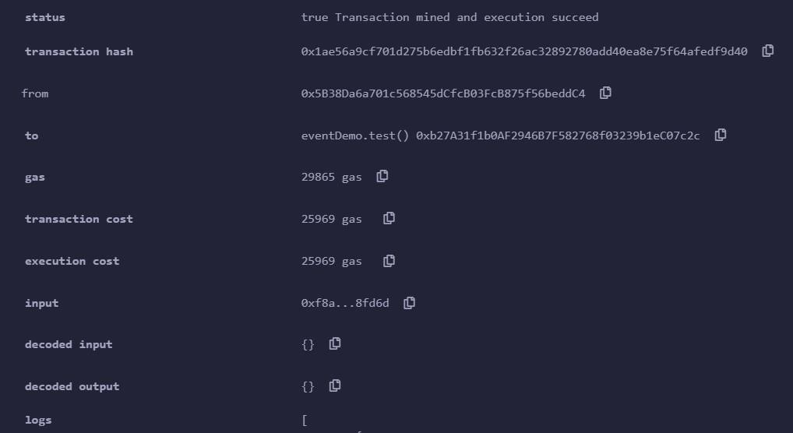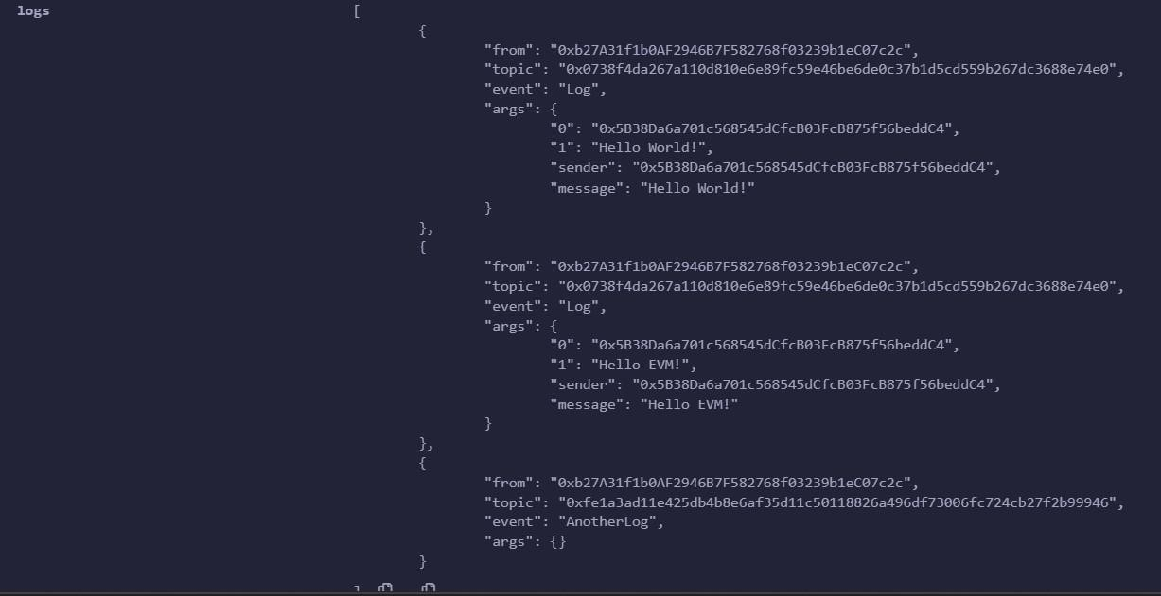

16.Write a solidity smart contract to demonstrate error handling.

pragma solidity 0.5.0; contract ErroHandling { function checkInput(uint _input) public view returns(string memory)

{

require(_input >= 0, "invalid uint8"); require(_input <= 255, "invalid uint8"); return "Input is Uint8";

}

function Odd(uint _input) public view returns(bool)

{

require(_input % 2 != 0); return true; }

}

Output:

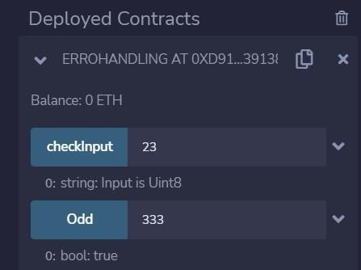

17.Write a solidity smart contract for Bank Account which provides operations such as check account balance, withdraw amount and deposit amount etc.

pragma solidity ^0.5.0; contract Banking{ mapping(address=>uint)public userAccount; mapping(address=>bool)public userExist;

function createAcc() public payable returns(string memory){ require(userExist[msg.sender]==false,'Account Alread Created'); if(msg.value==0){ userAccount[msg.sender]=0;

}

userAccount[msg.sender]=msg.value; userExist[msg.sender]=true; return 'account Created';

}

function deposite()public payable returns(string memory){ require(userExist[msg.sender]==true,'Account does not exist!'); require(msg.value>0,'value for deposite is zero');

userAccount[msg.sender]=userAccount[msg.sender]+msg.value; return 'Amount deposited successfully!';

}

function withdraw(uint amount)public payable returns(string memory){ require(userExist[msg.sender]==true,'Account does not exist!');

require(msg.value>0,'deposite value should greater than zero'); require(msg.value>= amount,'Amount shound be equal to or greater then balance'); userAccount[msg.sender]=userAccount[msg.sender]-amount; return 'Amount withdraw successfully!';

}

function transferAmount(address payable userAddress,uint amount)public payable returns(string memory){ require(userAccount [msg.sender]>amount,'insufficent balance in bank'); require(userExist[msg.sender]==true,'Account does not created'); require(userExist[userAddress]==true,'transfer Amount does not efficient'); require(amount>0,'Enter non zero value for sending');

userAccount[msg.sender]=userAccount[msg.sender]-amount;

userAccount[userAddress]=userAccount[userAddress]+amount; return 'transfer successfully';

}

function sendAmount(address payable toAddress , uint256 amount)public payable returns(string memory){ require(amount>0,'Enter non zero value for withdrawal'); require(userExist[msg.sender]==true,'Account does not created'); require(userAccount [msg.sender]>amount,'insufficent balance in bank');

userAccount[msg.sender]=userAccount[msg.sender]-amount; toAddress.transfer(amount);

return'transfer successfully';

}

function userAccountBalance()public view returns(uint) { return userAccount[msg.sender];

}

function accountExist()public view returns(bool) { return userExist[msg.sender];

}

}

Output:

